1. What is Node.js?
Answer:
Node.js is an JavaScript runtime environment built on Google's V8 engine

3. Is Node.js a programming language?
No.
Node.js is:
A JavaScript runtime environment.
JavaScript is:A programming language.

4. Is Node.js single-threaded?
Node.js is single-threaded for the JavaScript code, but it is multi-threaded behind the scene managing multiple tasks like file management,managing connections
Node.js uses a C++ library called libuv, which maintains a default pool of four background worker threads

5. What is the V8 Engine?
Simple Definition
V8 Engine is the javascript engine developed by google which converts JavaScript into machine code, making execution very fast.

7. What is the Node.js Runtime?
Simple Definition
A runtime environment provides everything necessary to execute a programming language.

2. What does "Non-blocking" mean?
Non-blocking means Node.js does not wait for a time-consuming I/O operation and moves to other tasks
When the I/O task completes, the system notifies Node.js via a callback, Promise, or event.

8. What are the advantages of Node.js?
1. Non-blocking I/O
Non-blocking I/O in Node.js means that input/output operations (like database queries, network requests, or file reading) do not pause the execution of the main JavaScript thread
When the I/O task completes, the system notifies Node.js via a callback, Promise, or event.
3. Huge npm Ecosystem
It’s hosts millions of javascript packages

3. What makes Node.js non-blocking?
Event Loop:
The Event Loop is the mechanism that allows Node.js to perform other tasks while waiting for input/output operations for initial task
2. Asynchronous APIs

1. What is Event-Driven Architecture?
Simple Definition
Event-Driven Architecture (EDA) is a software architecture where the application or system responds to events.
Ex:When an user wants to place an order,he clicks the PLACE_ORDER button and corresponding events gets generated and order will be placed

22. What is Async Programming?
Answer
Asynchronous programming allows a program to perform other tasks while the intial task waiting for I/O operations such as server responses
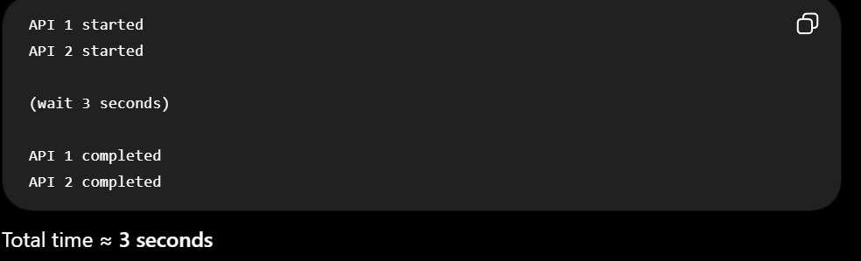
22. What is sync Programming?
Answer
Synchronous programming completes the initial task before starting another by waiting for I/O operations to respond
Here if the initial task required wait time of 10second for server to respond,its wait and completes the task before allowing other tasks to perform
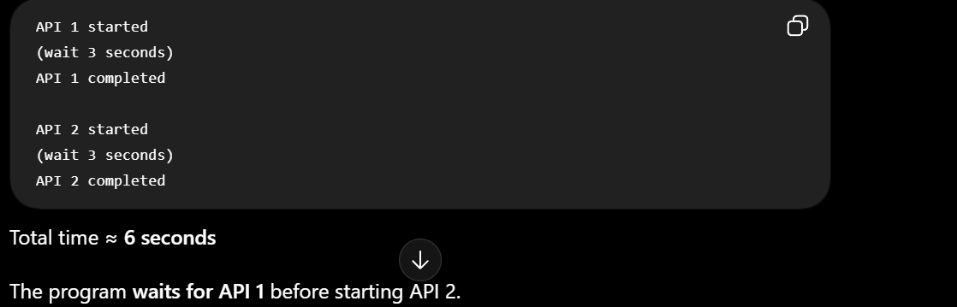

8. What are Callbacks?
Simple Definition
A callback is a function passed as an argument to another function and often executed an asynchronous task when an I/O operation—finishes
Callbacks will be in sync and async functions..In sync programming,callbacks are executed immediately in the outer function

9.What is Promise?
A Promise is a JavaScript object that represents the result of asynchronous function
It has three states: pending, fulfilled, and rejected.
We commonly handle promises using .then(), .catch(), and .finally().

10. What is async/await?
Simple Definition
async/await is syntax used in asynchronous programming to perform asynchronous operations

21. What is a Module in Node.js?
Simple Definition
A module is a reusable piece of code that can be imported and used in another file.

22. What are Built-in Modules?
Built-in modules are modules that come with pre-defined and pre-installed, so you don't need to install them using npm.
Examples:
Module | Purpose
fs | File system
http | HTTP server/client
path | File and directory paths
os | Operating system information
events | Event handling

23. What is the fs Module?
fs stands for File System.
It allows Node.js to interact with files and directories.

24. What is the http Module?
The http module is a built-in Node.js module used to create HTTP routes and make HTTP requests.

25. What is the path Module?
The path module provides utilities for working with file and directory paths.

26. What is the os Module?
The os module provides information about the operating system and machine and allows your scripts to interact directly with the underlying operating system

5. What is npm?
Answer:
npm (Node Package Manager) is the default package manager for Node.js.
It is used to:
- Install packages
- Update packages
- Remove packages
- Manage project dependencies
Example:
npm install express

6. What is package.json?
Answer:
package.json is the configuration file of a Node.js project.
It contains:
- Project name
- Version
- Dependencies
- Scripts
- Author
- License
Example:
{
"name":"myapp",
"version":"1.0.0",
"dependencies":{
"express":"^5.0.0"
}
}

7. What is package-lock.json?
Answer:
package-lock.json stores the exact versions of installed packages.

1. What is npm install?
npm install is used to install packages/dependencies required by a Node.js project.

2. Difference between dependencies and devDependencies
Both are packages used by a project, but they have different purposes.
dependencies
dependencies are core packages required for your app to run in production,Example:
npm install express
devDependencies
devDependencies are helper tools used only during local building, testing, and writing code.
Example:
npm install --save-dev nodemon
Nodemon is a tool that automatically restarts your server when it detects code changes

3. What is npm init?
npm init is used to create a new Node.js project.
Run:
npm init

4. What is node_modules?
node_modules is the folder where installed npm packages are stored.
For example:
npm install express

5. What is npx?
npx is a tool that allows you to execute npm packages/CLI tools without necessarily installing them globally.
For example:
npx create-vite my-app
This runs the create-vite tool to create a Vite project.

7. How do you use .env files in Node.js?
A .env file is commonly used to store environment variables during development.
Step 1: Install dotenv
npm install dotenv
Step 2: Load the .env file

1. How does Node.js handle multiple requests?
asynchronous, non-blocking I/O.

2. Difference between require() and import
Both are used to load modules in Node.js, but they belong to different module systems.
require()
require() Used by default in older Node.js apps
Import() used in modern Node.js files

3. What are environment variables?
Environment variables are configuration values stored outside the application code.

5. What are streams in Node.js?
Streams allow Node.js to process data piece by piece instead of loading the entire data into memory at once.
This is particularly useful for:
- Large files

6. How do you handle errors in Node.js?
Use try...catch.

7. How do you connect Node.js with MongoDB?
There are two common approaches:
1. MongoDB native driver
Install:
npm install mongodb
2. Mongoose
Install:
npm install mongoose
Mongoose is a library that provides a structured way to interact with MongoDB from Node.js

10. How does JWT authentication work in Node.js?
JWT authentication generally works like this:
Common authentication approaches include:
- JWT(Json Web Token)
- Step 1 — Login
- Step 2 — Server verifies credentials
- Step 3 — Server creates JWT
- Step 4 — Client receives token
- Step 5 — Client sends token
Step 6 — Server verifies JWT

